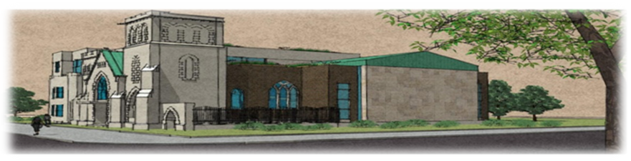

Dr. Oliver Jones Golf Tournament
Club de Golf Atlantide Golf Course,
2201 Boulevard Don Quichotte, Notre-Dame-de-l'Île-Perrot, QC J7V 7P2
Friday, August 19, 2016

GOLF REGISTRATION

Bring your own foursome or have us find you a group.
□ Sign me up for a foursome ($720.00) □ Sign me up per golfer ($180.00)

* * * * * * * * *
Please fill out the golfers’ names and complete the payment information.

Captain or Individual___________________________________________________________________
Address _____________________________________________________________________________
City, Province______________________________ Postal code_________________________________
Phone _________________________Email_________________________________________________
The Captain’s contact information is required. Addresses are necessary to mail tax receipts.
Golfer #2: ___________________________________________________________________________
Address: ____________________________________________________________________________
Golfer #3: ___________________________________________________________________________
Address: ____________________________________________________________________________
Golfer #4: ___________________________________________________________________________
Address: ____________________________________________________________________________
□ I have enclosed a cheque payable to the Union United Church; Foursome ($720) / Individual ($180)
Please mail cheque to Union United Church 3007 Delisle, Montreal, Quebec, H4C 1M8
Tax receipts will be provided for the eligible portion of the fees.
For more information, please contact June Keene Tel.: (514) 743-1397; Email: j_keene@hotmail.com or Athenia Charles Tel.: (514) 220-0538; Email: atheniacharles943@gmail.com

